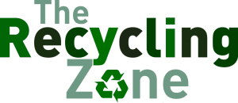
CORRUGATED CARDBOARD
- The cardboard used in packing with ruffled paper between two smooth sheets of paper.
- No contaminated cardboard by food wastes, oil, plastics or wax.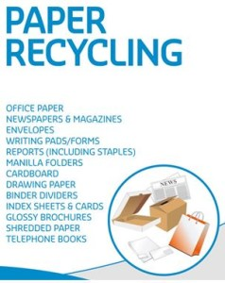
- Please flatten before disposal.
MIXED PAPER
- Construction paper, bond and other office papers, boxboard (cereal, tissue, cracker boxes etc.), glossy magazines, hard and soft cover books.
- Please place office shred in plastic bags
NEWSPRINT
- All newspaper including flyers.
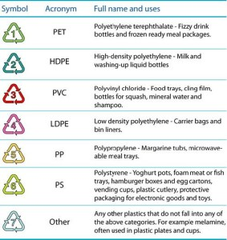
PLASTICS 1, 2, 4, 5 & 7
Plastic containers with the recycling symbol and the numbers 1, 2, 4, 5, or 7 in the symbol on the bottom of the container.
No motor oil or pesticide containers.
No food/shrink wrap or Styrofoam.
Please wash all items, remove lids or tops and flatten where possible

TIN CANS
- Please wash and remove labels as best as possible.
- Please crush the tin cans where possible.
- No paint cans.
- No large metal items – to be taken to the landfill directly.
- No tin foil.
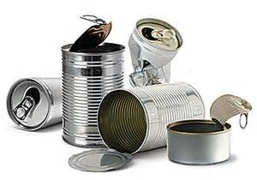
IMPORTANT NOTES
Wherever possible, take your pop bottles, pop cans etc. to your nearest SARCAN outlet. Similarly waste oil, tires, pesticide containers etc. have separately established locations for returns.
All of our recycle containers are now co-mingle. That means that all recyclable materials are able to go into the same container.

